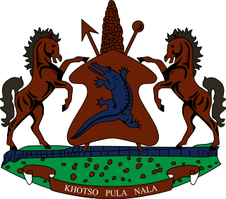

STATEMENT BY THE KINGDOM OF LESOTHO DURING THE 4TH UPR REVIEW OF SOUTH AFRICA

16 NOVEMBER, 2022

Thank you, Madam President,
Lesotho warmly welcomes the delegation of South Africa to the Working Group. We take cognizance of the steps taken by South Africa in various areas to promote and protect human rights of its people. We applaud South Africa for developing the legal and policy framework to address overcrowding in detention centers. We further commend them for taking strides in addressing the issue of child labour.
At this point, we wish to make the following recommendations for consideration by South Africa: 1. to redouble efforts to combat domestic violence against women and children. 2. To strengthen measures to curb human trafficking and ensure that all cases are investigated and prosecuted.
Finally, we wish South Africa every success with this UPR cycle.
I thank you

