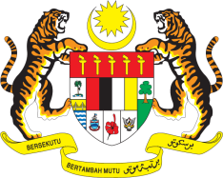

STATEMENT BY MALAYSIA
REVIEW OF SOUTH AFRICA
41ST SESSION OF THE UPR WORKING GROUP
7-18 NOVEMBER 2022

Malaysia welcomes the delegation of South Africa and thanks them for the presentation of their national report.

- Malaysia welcomes South Africa’s efforts in strengthening its national mechanism for reporting and follow-up through the establishment of NMRIF. Malaysia hopes that such efforts will be supported by the OHCHR and the international community through the provision of technical assistance and capacity-building.

- In the spirit of constructive engagement, Malaysia recommends the following:

3.1 Strengthen its efforts to prevent HIV/AIDS transmissions including by raising awareness and providing affordable medicines to people in need of life-saving treatment;

3.2 Continue its efforts to prevent and combat trafficking in persons in all its forms and manifestation through effective implementation of the Prevention and Combating of Trafficking in Persons Act, focusing on data collection and capacity-building for officials in implementing the Act.

- We wish South Africa a successful review.

Thank you.

16 NOVEMBER 2022
GENEVA

