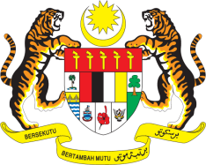

STATEMENT BY MALAYSIA
REVIEW OF THE KINGDOM OF THE NETHERLANDS
41ST SESSION OF THE UPR WORKING GROUP
7-18 NOVEMBER 2022

Malaysia thanks the Kingdom of the Netherlands for the presentation of its national report.

- Malaysia also welcomes the Kingdom of the Netherlands’ continuous engagement in the UPR process We appreciate that the Government has acknowledged that response to discrimination and racism needs to be improved. We wish to recommend the following:

3.1. Advance the right to adequate housing for all including by addressing the root causes of homelessness; and

3.2. Strengthen existing legal framework to adequately address and prevent sexual harassment.

- We wish the Kingdom of the Netherlands a successful review.

Thank you.

15 NOVEMBER 2022
GENEVA

