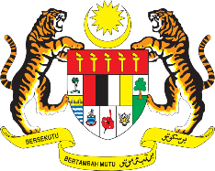

STATEMENT BY MALAYSIA
REVIEW OF POLAND
41ST SESSION OF THE UPR WORKING GROUP
7 – 18 NOVEMBER 2022

Malaysia thanks Poland for the comprehensive presentation of its national report.

- Malaysia commends Poland for its commitment in the promotion and protection of human rights for vulnerable groups, including women and children, persons with disabilities, ethnic minorities, migrants and refugees, among others. We also applaud the commitment of Poland to initiate judicial reform with a view to improve the functioning of the justice system.

- In the spirit of constructive engagement, Malaysia recommends the following:

  - Strengthen policies and programmes to eliminate violence against women, including domestic violence;

  - Continue efforts to improve the situation of persons with disabilities, by ensuring employment and adequate access to rehabilitation; and

  - Combat racist hate speech and incitement to violence, including on the Internet.

- We wish Poland a successful review.

Thank you.

15 NOVEMBER 2022
GENEVA

