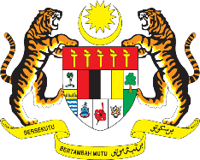

STATEMENT BY MALAYSIA
REVIEW OF BRAZIL
41ST SESSION OF THE UPR WORKING GROUP
7 – 18 NOVEMBER 2022

Malaysia thanks Brazil for the comprehensive presentation of its national report.

- Malaysia commends Brazil for its commitment in protecting the rights of the vulnerable groups, especially the Indigenous Peoples that had been impacted by the COVID-19 pandemic. We are also pleased to note that Brazil has taken progressive steps and working with relevant UN agencies in tackling violence against women and children, human trafficking, as well as strengthening its healthcare systems.

- In the spirit of constructive engagement, Malaysia recommends the following:

  - Improve the access and quality of public education, especially for population in the rural areas and ethnic minorities;

  - Increase the level of investments in HIV prevention programmes; and

  - Strengthen legal framework and implement educational and judicial measures to eradicate racism and discrimination.

- We wish Brazil a successful review.

Thank you.

14 NOVEMBER 2022
GENEVA

