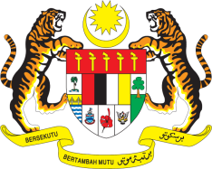

STATEMENT BY MALAYSIA
REVIEW OF THE PHILIPPINES
41ST SESSION OF THE UPR WORKING GROUP
7-18 NOVEMBER 2022

Thank you Chair,

Malaysia thanks the Philippines for its report.

- Malaysia commends the Philippines for the various efforts taken to promote and protect human rights of its people. We encourage the Philippines to continue implementing robust and pragmatic policies, especially those targeted for specific groups such as women, children and persons with disabilities. Malaysia also appreciates the Philippines’ important contribution to ASEAN Community building and the realisation of the ASEAN common human rights agenda.

- In the spirit of constructive engagement, Malaysia recommends the following:

3.1 Strengthen efforts in creating a safe space for women and children online, including through intensified awareness-raising campaign against all forms of sexual exploitation and abuse; and

3.2 Ensure effective implementation of the Basic Education Development Plan 2030, particularly in terms of expanding access to quality education for children and youth in disadvantaged situations

- Malaysia wishes the Philippines every success in the implementation of its Fourth UPR.

Thank you.

14 NOVEMBER 2022
GENEVA

