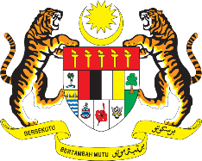

STATEMENT BY MALAYSIA
REVIEW OF ALGERIA
41ST SESSION OF THE UPR WORKING GROUP
7 – 18 NOVEMBER 2022

Malaysia thanks Algeria for its report’s presentation.

- Malaysia commends Algeria on its commitments to strengthen the independence of judiciary, combating corruption as well as addressing trafficking in persons. Algeria has also made positive steps to reduce avoidable maternal mortality through various programmes.

- In the spirit of constructive engagement, Malaysia recommends the following:

  - Intensify efforts to strengthen its policies and strategies aimed at addressing trafficking in persons, especially women and children; and

  - Strengthen health policies and programmes to reduce preventable maternal mortality and neonatal deaths.

- We wish Algeria a successful review.

Thank you.

11 NOVEMBER 2022
GENEVA

