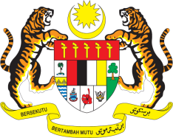

STATEMENT BY MALAYSIA
REVIEW OF INDIA
41ST SESSION OF THE UPR WORKING GROUP
7-18 NOVEMBER 2022

Malaysia thanks India for its report.

- Malaysia welcomes India’s pragmatic, transparent and inclusive approach in advancing the rights of the most vulnerable. We encourage India to continue efforts to eliminate all forms of malnutrition by increasing food security, and provide adequate housing for all.

- In the spirit of constructive engagement, Malaysia recommends the following:

3.1 Consider establishing the National Mechanism for Implementation and Follow-up (NMRF) for effective implementation of UPR recommendations, taking into account the national context;

3.2 Consider strengthening legal and policy measures to ensure the right to privacy; and

3.3 Take concrete steps to raise awareness on and eliminate extremist ideology that promotes and condones violence and discrimination against religious minorities in India.

- We wish India a successful review.

Thank you.

10 NOVEMBER 2022
GENEVA

