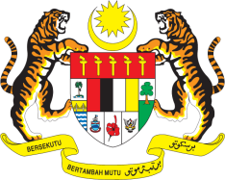

STATEMENT BY MALAYSIA
REVIEW OF THE UNITED KINGDOM
41ST SESSION OF THE UPR WORKING GROUP
7-18 NOVEMBER 2022

Malaysia welcomes the delegation of the UK and thanks them for the presentation of their national report.

- Malaysia welcomes the UK’s strong commitment to advance human rights and commend its efforts in tackling violence against women and girls. However, improvements could still be made and in the spirit of constructive engagement, Malaysia recommends the following:

2.1 Develop a comprehensive nationwide anti-poverty strategy and eliminate child poverty;

2.2 Continue to refine its policies to combat all forms of hate crimes, particularly those against racial and religious minorities; and

2.3 Intensify efforts to combat human trafficking and all forms of slavery.

- We wish the UK a successful review.

Thank you.

10 NOVEMBER 2022
GENEVA

