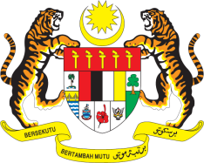

STATEMENT BY MALAYSIA
REVIEW OF FINLAND
41ST SESSION OF THE UPR WORKING GROUP
7-18 NOVEMBER 2022

Malaysia thanks Finland for its report.

- Malaysia commends Finland for the multistakeholder consultations undertaken in the preparation of its Fourth UPR, as well as its Third National Action Plan on Fundamental and Human Rights and hope for its successful implementation.

- In the spirit of constructive engagement, Malaysia recommends the following:

3.1 Continue strengthening measures to end domestic violence, including by improving the process for legal recourse for victims; and

3.2 Continue to address the issue of racial and ethnic profiling, including amongst its enforcement officials.

- We wish Finland a successful review.

Thank you.

9 NOVEMBER 2022
GENEVA

