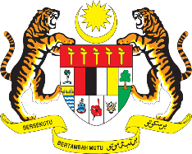

STATEMENT BY MALAYSIA
REVIEW OF INDONESIA
41ST SESSION OF THE UPR WORKING GROUP
7 – 18 NOVEMBER 2022

Malaysia thanks Indonesia for its report.

- Malaysia commends Indonesia for its continuous efforts to improve the welfare and wellbeing of its people including by advancing human rights of vulnerable groups, such as women, children, persons with disabilities and ‘adat’ communities. Malaysia also appreciates Indonesia’s contribution to ASEAN Community building, as well as to the realisation of the ASEAN common human rights agenda.

- In the spirit of constructive engagement, Malaysia recommends the following:

  - Strengthen measures to ensure the effective and timely implementation in the priority areas set forth in the women’s empowerment and child protection plan; and

  - Take all necessary measures to ensure inclusive learning environment for children with disabilities, including by increasing adequate school facilities and comprehensive curriculum;

- Malaysia wishes Indonesia every success in its Fourth UPR.

Thank you.

9 NOVEMBER 2022
GENEVA

