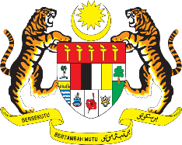

STATEMENT BY MALAYSIA
REVIEW OF MOROCCO
41ST SESSION OF THE UPR WORKING GROUP
7 – 18 NOVEMBER 2022

Malaysia thanks Morocco for its report’s presentation.

- Malaysia commends Morocco for the commitments on human rights reflected in the strengthening of institutional frameworks. Morocco also made progressive steps in ensuring access to education, reducing unemployment and increasing female participation in the labour market.

- In the spirit of constructive engagement, Malaysia recommends the following:

  - Continue implementing targeted measures to improve the situation of women, especially their access to health care;

  - Continue to ensure the physical, emotional well-being and welfare of children; and

  - Continue taking steps to facilitate more employment opportunities for youth.

- We wish Morocco a successful review.

Thank you.

8 NOVEMBER 2022
GENEVA

