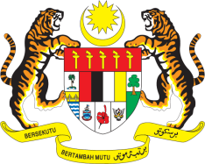

STATEMENT BY MALAYSIA
REVIEW OF TUNISIA
41ST SESSION OF THE UPR WORKING GROUP
7-18 NOVEMBER 2022

Malaysia thanks Tunisia for the presentation of its national report.

- Malaysia commends Tunisia’s efforts in increasing capacity building and human rights training for judges and social workers. We encourage continuous engagement with the OHCHR and the UN system on capacity building and training, for other stakeholders such as enforcement officers.

- In the spirit of constructive engagement, Malaysia recommends the following:

3.1 Continue taking steps in strengthening existing law to combat all forms of violence against women;

3.2 Intensify efforts to bring domestic legislation in line with international standards to promote and protect the rights of persons with disabilities; and

3.3 Continue efforts towards the development of action plans to follow up on the implementation of recommendations made by human rights mechanisms.

- We wish Tunisia a successful review.

Thank you.

8 NOVEMBER 2022
GENEVA

