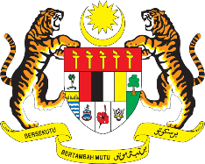

STATEMENT BY MALAYSIA
REVIEW OF ECUADOR
41ST SESSION OF THE UPR WORKING GROUP
7 – 18 NOVEMBER 2022

Malaysia thanks Ecuador for the comprehensive presentation of its national report.

- Malaysia commends Ecuador for steps taken to better comply with its human rights obligations, including through the submission of the voluntary midterm report as well as the strengthening of the follow-up mechanism for the recommendations from the human rights mechanisms. We also welcome various efforts made by the Ecuador Government to protect the rights of women and children, especially through relevant legislation and policies to prevent violence, provide prompt response and timely care.

- In the spirit of constructive engagement, Malaysia recommends the following:

  - Increase efforts to promote the right to education for persons with disabilities;

  - Continue to ensure equality for women in law and in practice and combat all forms of gender-based violence; and

  - Continue taking steps to develop a national action plan on business and human rights in line with the implementation of the Guiding Principles on Business and Human Rights.

- We wish Ecuador a successful review.

Thank you.

7 NOVEMBER 2022
GENEVA

