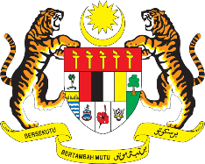

STATEMENT BY MALAYSIA
REVIEW OF BAHRAIN
41ST SESSION OF THE UPR WORKING GROUP
7 – 18 NOVEMBER 2022

Malaysia thanks Bahrain for the comprehensive presentation of its national report.

- Malaysia commends Bahrain for its commitment to realise the Sustainable Development Goals, including by establishing a Ministry of Sustainable Development. Despite the major challenge posed by COVID-19 pandemic, Malaysia is pleased to note that Bahrain continues to ensure delivery of healthcare, educational and economic rights for all. Notably, Bahrain had taken various measures to protect women and children from all forms of ill-treatment and violence.

- In the spirit of constructive engagement, Malaysia recommends the following:

  - Work to strengthen gender equality procedures in access to adequate housing; and

  - Continue to support projects related to childhood and the development of abilities and skills in children.

- We wish Bahrain a successful review.

Thank you.

7 NOVEMBER 2022
GENEVA

