aJamhuuriyadda Federaalka Soomaaliya  Ergada Joogtada Soomaliyeed ee Qaramada Midoobey ee Geneva, Switzerland. | 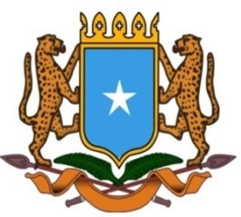 | جمهورية الصوما ل الفيدرالية  البعثة الدائمة لجمهورية الصومال بمكتب الأمم المتحدة بجنيف وبالوكالات المتخصصة بسويسرا

Permanent Mission of the Federal Republic of Somalia to the United Nations Office at Geneva and Other International Organizations in Switzerland

Check Against Delivery

Statement by the Delegations of Somalia,
H.E Ms. Ebyan Mahamed Salah, Ambassador/Permanent Representative
at the Review of the Republic of South Africa, during the 41th Session of the UPR Working Group on Wednesday, 14 November 10, 2022 from 9:00AM to 12:30PM, in the Room XX of the Palais des Nations in Geneva, Speaker Number 47, Time: 1:00 minute.

Thank you, Mr President,

Somalia warmly welcomes the delegation of the Republic of South Africa and their outstanding country report.

We commend the efforts and progress made by South Africa since the third cycle of the Review in accordance with the various recommendations made. Somalia appreciates South Africa’s commitment to making progress on the promotion and protection of Human Rights and continued effort in Cooperation with International, Regional and National mechanisms.

Somalia Recommends the following:

- To ratify pending international human rights instruments.
- To Strengthen South Africa’s National Human Rights Commission and increase its national budget allocation.
- To put in place a national action plan to combat racism, racial discrimination, xenophobia, and related intolerance.

We wish the Republic of South Africa a successful UPR review

I Thank you Mr President.

