aJamhuuriyadda Federaalka Soomaaliya  Ergada Joogtada Soomaliyeed ee Qaramada Midoobey ee Geneva | 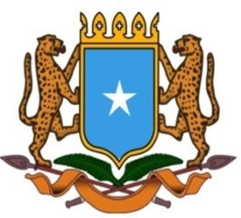 | جمهورية الصوما ل الفيدرالية  البعثة الدائمة لجمهورية الصومال بمكتب الأمم المتحدة بجنيف وبالوكالات المتخصصة بسويسرا

Permanent Mission of the Federal Republic of Somalia to the United Nations Office at Geneva and other International Organizations in Switzerland
Check Against Delivery

Statement by the Delegations of Somalia,
Mr. Salah Moallim Abubakar, Second Counsellor
at the Review of the People’s Democratic Republic of Algeria, during the 41th Session of the UPR Working Group on Tuesday, 11 November, 2022 from 9:00AM to 12:30PM, in the Room XX of the Palais des Nations in Geneva, Speaker Number 112, Time: 00 minute and 55 seconds.

Thank you Mr. President,

Somalia warmly welcomes the distinguished delegation of the People’s Democratic Republic of Algeria, to this UPR Working Group, and commends Algeria for its legislative, institutional and policy initiatives to promote and protect human rights principles and values, including the constitutional amendment that strengthened its democratic institution and the creation of the National Observatory for the Prevention of Discrimination and Hate Speech.

In the spirit of constructive dialogue, Somalia recommends the following for consideration :

- Continue promoting sustainable economic and social development and raising the living standard of its people so as to lay down a firm basis for the enjoyment of human rights by its people.

- Continue efforts aimed at improving the access of persons with disabilities to education, vocational training and health care.

- - Continue the training programs aimed at raising awareness of human rights, and disseminating them in public institutions and public sectors in accordance with international standards for human rights principles

In conclusion, my delegation wishes the delegation of the People's Democratic Republic of Algeria every success in this UPR cycle.

