aJamhuuriyadda Federaalka Soomaaliya  Ergada Joogtada Soomaliyeed ee Qaramada Midoobey ee Geneva | 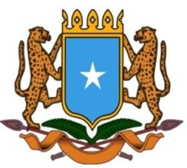 | جمهورية الصوما ل الفيدرالية  البعثة الدائمة لجمهورية الصومال بمكتب الأمم المتحدة بجنيف وبالوكالات المتخصصة بسويسرا

Permanent Mission of the Federal Republic of Somalia to the United Nations Office at Geneva and Other International Organizations in Switzerland

Check Against Delivery

Statement by the Delegations of Somalia,
H.E Ms. Ebyan Mahamed Salah, Ambassador/Permanent Representative
at the Review of the United Kingdom, during the 41th Session of the UPR Working Group on Thursday, 10 November 10, 2022 from 9:00AM to 12:30PM, in the Room XX of the Palais des Nations in Geneva, Speaker Number 47, Time: 1:00 minute.

Thank you Mr. President,

Somalia warmly welcomes the distinguished delegation of the United Kingdom to this UPR Working Group, and congratulates for the presentation of their comprehensive national report as well as its genuine commitment to the UPR process.

Somalia further welcomes the pro-active and leading role that UK is playing on the human rights issues at international level and the progress achieved in the promotion of the civil and political rights of its citzens, by implementing a strategic policy based on the principle of equality and non- discrimination before the law.

Somalia recommends the following :

- To ratify the International Convention on the Protection of the Rights of All Migrant Workers and Members of Their Families.

- To established international refugee protection asylum seeker system, which is in conformity with the international standard and conventions.

- To develop an effective employment policy, specific for persons with disabilities.

Somalia wishes every success to the distinguished delegation of UK in this review.
I Thank you Mr. President.

