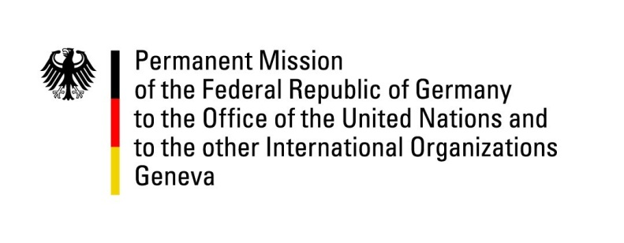

United Nations Human Rights Council

41st Session of the UPR Working Group

Geneva, 16th of November 2022

German Recommendations to

South Africa

Mr. President,
Germany welcomes the delegation of South Africa and commends South Africa for its progress in fighting child mortality and thus advancing SDG No. 4.

Germany remains concerned about the state of migrant rights, the right to education and gender-based violence.

Germany therefore recommends to:
- Protect and fulfil migrants' rights, in particular by effectively prosecuting offences committed against them, by ensuring access to education for children and by improving migrants’ living conditions.
- Improve on equal chances for the youth irrespective of families’ socioeconomic situation or ethnic background or gender, in particular by ensuring equal access to quality primary, secondary and tertiary education.
- Enhance measures to protect victims of gender based and sexual violence from secondary victimisation by frontline workers, such as police, ensure access to justice by tackling the backlogs and duration of court cases, and create sufficient shelter infrastructure.

Thank you, Mr. President.

