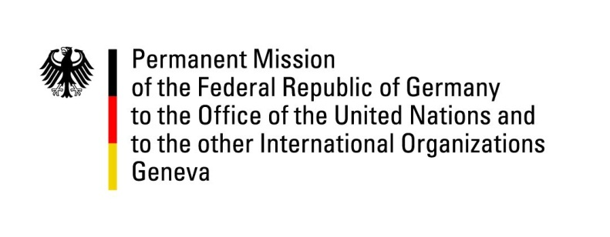

United Nations Human Rights Council

41st Session of the UPR Working Group

Geneva, 15th of November 2022

German Recommendations to

The Kingdom of the Netherlands

Mister President,
Germany welcomes the delegation of the Kingdom of the Netherlands. We commend the Dutch efforts to uphold and strengthen human rights. We applaud that structures and persons responsible for racial profiling in investigations against cases of child benefits abuse were held accountable. We also welcome the efforts to increase the protection of migrant workers. The Netherlands are a committed partner in protecting human rights world-wide.

Germany would like to point out remaining concerns about the effects of organized crime on human rights, the state of anti-discrimination legislation in Dutch territories in the Caribbean, and the full implementation of the Istanbul Convention.

Germany therefore recommends:

- To extend the application of anti-discrimination legislation to Dutch territories in the Caribbean
- To Fully and swiftly implement the Istanbul Convention
- And to implement, monitor and enforce Dutch mandatory human rights and environmental due diligence legislation

Thank you, Mister President.

