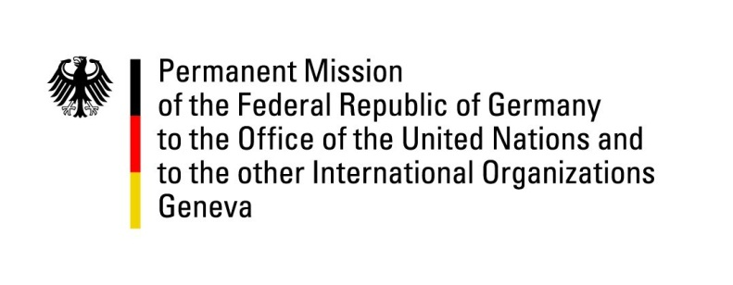

United Nations Human Rights Council

41st Session of the UPR Working Group

Geneva, 11th of November 2022

German Recommendations to

Brazil

Mister President,
Germany welcomes the delegation of Brazil. Germany commends Brazil for passing legislation on pre-trial detention hearings, as recommended by Germany in the last UPR cycle.

Germany remains concerned about the high number of attacks against and killings of human rights defenders. We regret that the demarcation and registration of indigenous lands had stopped.

Germany recommends:
- To protect indigenous peoples from threats and attacks and guarantee their land rights, in particular by resuming and completing land demarcation processes, providing adequate resources to the National Indian Foundation, fully recognizing Autonomous Consultations and Consent Protocols, and strengthening Land Protection Orders.
- To end extrajudicial killings by police units and associated impunity, including by expanding the use of less-lethal weapons and body-cams.
- And to ensure that the national programme for the protection of Human Rights Defenders, is implemented in all States and adequately funded.
Thank you, Mister President.

