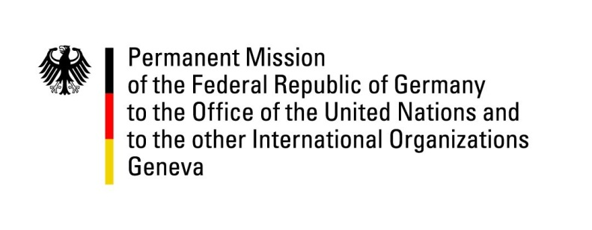

United Nations Human Rights Council

41st Session of the UPR Working Group

Geneva, 14th of November 2022

German Recommendations to

Algeria

Mister President,
Germany welcomes the delegation of Algeria.

Germany commends Algeria for strengthening certain civic rights as part of its 2020 constitutional reform, especially rights of women and children and concerning the Berber language Amazigh.

Germany encourages Algeria to ensure space for civil society, to cooperate with UNHRC mechanisms and to grant access for UNHRC mandate holders. Germany is deeply concerned about the human rights defenders who were prevented from participating in the UPR pre-session.

Germany therefore recommends:
- To reform family law to end legal discrimination of women and to ensure gender equality as stipulated in Art. 37 of the Constitution.
- To reform Art. 87bis of the Penal Code to end restrictions to the constitutionally guaranteed freedom of opinion.
- And to adopt an asylum law to ensure protection.

Thank you, Mister President.

