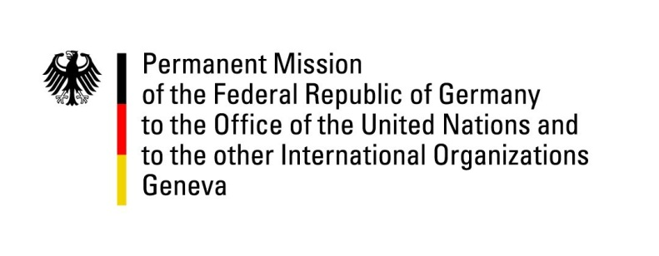

United Nations Human Rights Council

41st Session of the UPR Working Group

Geneva, 10th of November 2022

German Recommendations to

United Kingdom of Great Britain and Northern Ireland

Mister President,
Germany welcomes the delegation of the United Kingdom of Great Britain and Northern Ireland. We commend the ratification of the Istanbul Convention. The UK is a committed partner in protecting Human Rights worldwide.

Germany remains concerned about the rights of migrants, asylum seekers and refugees, and the possible reform of the Human Rights Act 1998.

Germany recommends to:

- Ensure that any possible reform to the Human Rights Act 1998 does not weaken the protection or limit the ability of individuals to enjoy and enforce rights under the European Convention on Human Rights
- Ensure all women and girls are equally protected from violence,
- Introduce a general statutory time limit on detention pending deportation
- Remain committed to fully implement the European Convention on Human Rights

Thank you, Mister President.

