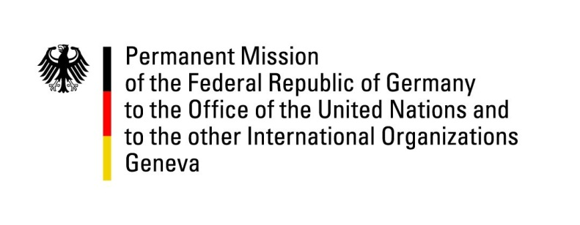

United Nations Human Rights Council

41st Session of the UPR Working Group

Geneva, 09th of November 2022

German Recommendations to

The Republic of Finland

Mister Vice President,
Germany welcomes the delegation of the Republic of Finland. We commend Finland for its remarkable engagement in advancing human rights world-wide.

Germany would like to point out remaining concerns about the rights of marginalized groups, specifically the Sámi people, religious minorities, and minorities of sexual orientation and gender identity.

Germany therefore recommends to:
- Advance the Free Prior and Informed Consent principles in all laws, and political as well as official decisions regarding the rights for the Sámi people.
- Ratify the ILO Indigenous and Tribal Peoples Convention No. 169.
- Increase resources for efforts against violence against women, including legal accountability, as well as offering trauma-responsive care.
- Revise antidiscrimination laws and equal opportunity legislation to provide better and intersectional victim protection.
- Finally improve conditions for wage equity.

Thank you, Mister Vice President.

