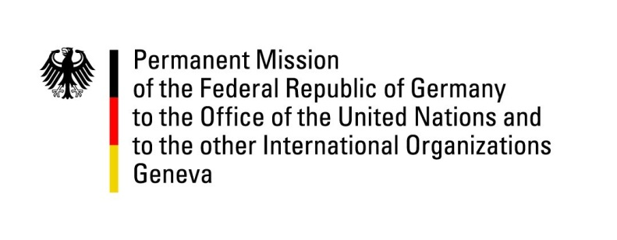

United Nations Human Rights Council

41st Session of the UPR Working Group

Geneva, 07th of November 2022

German Recommendations to

Morocco

Mister President,
Germany welcomes the delegation of Morocco.

Germany commends Morocco for acceding to the Istanbul Convention, founding the National Commission for the protection of women victims of violence and adopting a National WPS Action Plan.

Germany remains concerned about the constraints to individual liberties, press freedom and freedom of expression.

Germany encourages Morocco in its reforms to ensure the protection of women’s and children’s rights.

Germany therefore recommends to:
- End discrimination and criminalization of single mothers and to guarantee legal recognition of children born outside of marriage and to introduce DNA paternity tests.
- Adapt family law in order to prevent child marriages.
- Adapt family law in order to guarantee equality of men and women in inheritance and guardianship matters.

Thank you, Mister President.

