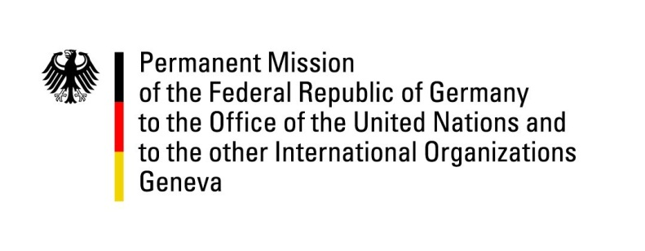

United Nations Human Rights Council

41st Session of the UPR Working Group

Geneva, 8th of November 2022

German recommendations to

Tunisia

Mister Vice President,
Germany welcomes the delegation of Tunisia.
Germany remains concerned about certain developments regarding the human rights situation in the country, in particular the erosion of civil and political rights by a lack of independent institutional safeguards and the uncertain legal situation of the elected members of the Tunisian Parliament.

Germany therefore recommends:

- to establish an independent Constitutional Court according to Chapter VI of the Constitution and equip it with adequate powers and resources to ensure independence and effective decision taking,
- to reform the Criminal Code and Criminal Procedure Code in line with the constitution and international human rights obligations,
- to immediately end the practice of trying civilians in military courts and amend the Military Justice Code to abolish the jurisdiction of military courts over civilians,
- to revise the Personal Status Code, which establishes the husband as head of the family, does not recognize the same rights to men and women in exercising parental responsibilities and imposes abstinence on the wife in the event of divorce or widowhood,
- and to repeal article 230 of the Criminal Code criminalizing homosexuality, and all the articles invoked to arrest and bring to trial LGBTI persons.

Thank you, Mister Vice President.

