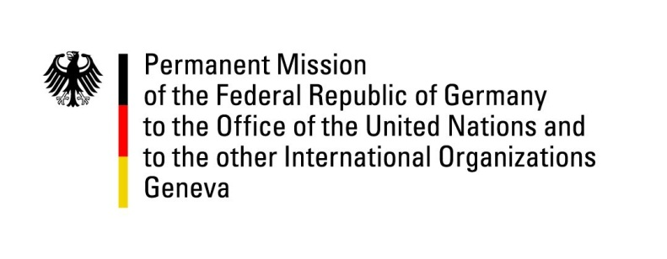

United Nations Human Rights Council

41st Session of the UPR Working Group

Geneva, 07th of November 2022

German Recommendations to

The Republic of Ecuador

Mister Vice President,
Germany welcomes the delegation of the Republic of Ecuador. We acknowledge Ecuador’s efforts to advance important human rights issues in recent years. Particularly, we appreciate improvements concerning environmental protection and freedom of opinion, as well as measures towards the reduction of poverty and the discrimination of LGBTI, persons with disabilities and older persons.

Germany remains concerned about the conditions in prisons, specifically the situation for juveniles and young adults.

Germany therefore recommends to:
- Invest in training and capacity of prison staff as well as measures that would shorten pre-trial detention in order to decrease the overcrowding of prisons.
- Concerning violence against children and juveniles, to establish “support stations” and shelters for young survivors of abuses, staffed by trained personnel enjoying the survivors’ trust.
- Concerning violence against women, to expand specialized law enforcement departments for “gender violence” in police and public prosecution departments.

Thank you, Mister Vice President.

