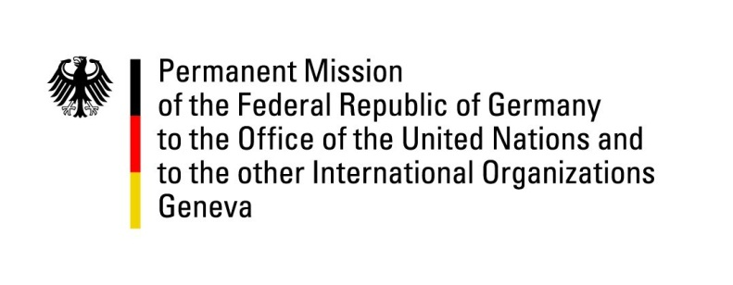

United Nations Human Rights Council

41st Session of the UPR Working Group

Geneva, 07th of November 2022

German Recommendations

Bahrain

Mister President,
Germany welcomes the delegation of Bahrain and commends Bahrain for its efforts to improve the human rights situation in accordance with its National Human Rights Plan, including the development of restorative justice mechanisms as well as the active promotion of freedom of belief.
Germany remains concerned about the human rights situation especially regarding the right of freedom of opinion and expression as well as the right to peaceful assembly. We also regret the resuming use of the death penalty.

Germany therefore recommends to:
- Return to a de facto moratorium on the use of the death penalty.
- Reduce restrictions on peaceful assembly and association and protect the rights to freedom of opinion and expression as well as freedom of assembly in accordance with international obligations.
- Strengthen anti-discrimination legislation to ensure that foreign nationals, particularly migrant workers, are treated equally before the law.

Thank you, Mister President.

