Jamhuuriyadda Federaalka Soomaaliya  Ergada Joogtada Soomaliyeed ee Qaramada Midoobey ee Geneva | 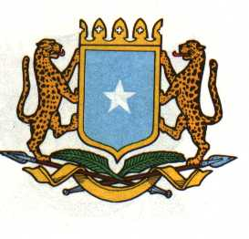 | الفيدرالية ل جمهورية الصوما  البعثة الدائمة لجمهورية الصومال بمكتب الأمم المتحدة بجنيف وبالوكالات المتخصصة بسويسرا
Check Against Delivery

THE FEDERAL REPUBLIC OF SOMALIA
Permanent Mission of the Federal Republic of Somalia to the United Nations Office at Geneva and other International Organizations in Geneva

Statement by the Delegations of Somalia,
H.E Ms. Ebyan Mahamed Salah, Ambassador/Permanent Representative
at the Review of the Kingdom of Morocca, during the 41th Session of the UPR Working Group on Tuesday, 08 November, 2022 from 12:30PM to 18:00PM, in the Room XX of the Palais des Nations in Geneva, Speaker Number 9, Time: 55 Seconds.

Thank you, Mr. President,
Somalia commends the High-Level Delegation from the Kingdom of Morocco and thanks them for presenting an outstanding comprehensive National Report.
Somalia commends the adoption of the National Sustainable Development Strategies on 2030 with the aim of integrating into various national strategies, in particular eradicating poverty and reducing social disparities, also ensuring an inclusive and equitable quality education services, among other objectives
Somalia recommends the following:
- Further enhance the measures in favor of human rights and operationalize the fight against all forms of discriminations.
- Continue to Promote and Protect the Rights of Persons with Disabilities.
- Ensure equality in education for women especially in rural areas.
Somalia wishes the delegation of the Kingdom of Morocco every success in this 4th cycle of the Universal Periodic Review UPR.

Thank you, Mr. President

