Jamhuuriyadda Federaalka Soomaaliya  Ergada Joogtada Soomaliyeed ee Qaramada Midoobey ee Geneva | 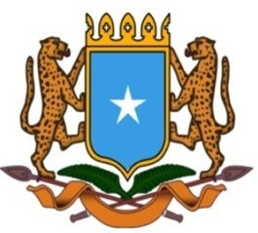 | جمهورية الصوما ل الفيدرالية  البعثة الدائمة لجمهورية الصومال بمكتب الأمم المتحدة بجنيف وبالوكالات المتخصصة بسويسرا

Permanent Mission of the Federal Republic of Somalia to the United Nations Office at Geneva and other International Organizations in Switzerland

Check Against Delivery

Statement by the Delegations of Somalia,
Mr. Hussen Abdi Musa, First Counsellor
at the Review of the Republic of Tunisia, during the 41th Session of the UPR Working Group on Tuesday, 08 November, 2022 from 9:00AM to 12:30PM, in the Room XX of the Palais des Nations in Geneva, Speaker Number 117, Time: 1 minute and 00 seconds.

Thank you Mr. President,

Somalia warmly welcomes the distinguished delegation of the Republic of Tunisia, to this UPR Working Group, and congratulates on the quality of their national report and presentation which is very informative and comprehensive.

Somalia commends the great progress achieved by Tunisia since its last UPR review on the situation of human rights in the country, and in particular the reform initiated by the government since July 2021 which led the adoption of a new constitution that further enhanced all fundamental human rights, the rule of law and democracy.

In the spirit of constructive dialogue, Somalia recommends the following for consideration :

- To continue strengthening capacity building and education in the field of human rights,
- To promote the rights of children with disabilities by implementing effective measures that ensure an appropriate and inclusive education,
- Continuing efforts to address school dropouts, especially in rural areas.
- Continue implementing the reform of the national health system with a view to guarantee to all citizens the right to health and social coverage and to enhance regional equality by eliminating the barriers to access to healthcare services.
To conclude, Somalia wishes the distinguished delegation of Tunisia every success in this review
I Thank you Mr. President.

