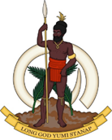
Statement delivered by Sumbue ANTAS,
Ambassador/ Permanent Representative of the Republic of Vanuatu to the United Nations and other International Organisations in Geneva

41st Session of the Working Group of the Universal Periodic Review
Review of Algeria

11.11.2022

Thank you, Mr. President.

Vanuatu welcomes the delegation of Algeria and thanks them for the presentation and would like to offer the following recommendations:

- Remove reservation on art 2 of the CEDAW;
- Implement effective policies to prevent and address the negative impacts of climate change and reduce disaster risk, especially for vulnerable people living in remote areas.
- Extend standing invitation and fully cooperate with all UN Special Procedures.
Vanuatu wishes Algeria a successful review.
Thank you

