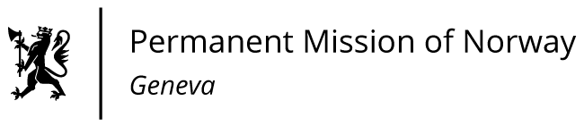

STATEMENT

41th UPR Session of the Human Rights Council

on the human rights situation in Netherlands,

as delivered by as delivered by Ms Anniken ENERSEN

Minister Counsellor, Human Rights

Check against delivery
11 November 2022

President,

Norway acknowledges the steps the Netherlands has taken to combat discrimination and racism, and sexual violence against women, as well as to promote gender equality.

Norway recommends that the Netherlands:

1) ensures measurable improvement of the economic independence of women and their position in the labour market by explicitly considering women in plans for earmarked shared parental leave, more fulltime work, and better access to childcare;

2) revisits the long-term aspects of the system for asylum reception to ensure compliance with Article 3 of the European Convention on Human Rights;

3) addresses the root causes of institutional racism and reviews existing and future laws, policies and practices in order to prevent bias and discrimination.

Thank you.

