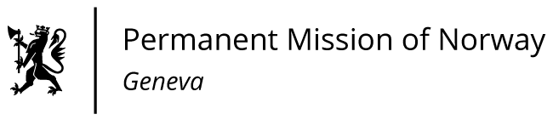

STATEMENT

41st UPR Session of the Human Rights Council

on the human rights situation in Poland,

as delivered by Ms Jannicke Graatrud,

Minister, Deputy Permanent Representative.

Check against delivery
15 November 2022

President,
Norway appreciates Poland's efforts to receive Ukrainian refugees.
[Norway is concerned by developments in Poland relating to the rule of law and judicial independence and respect for fundamental freedoms and human rights.]

Norway recommends that Poland:

1) ensures swift implementation of the relevant ECJ [European Court of Justice] and ECHR [European Court of Human Rights] judgments and the recommendations of the European Commission’s Rule of Law Report to safeguard the rule of law and the independence of the Polish judiciary;

2) adopts a legal framework that fosters a free, independent and pluralistic media, and ensures the protection of journalists from persecution, intimidation and harassment;

3) significantly improves women’s rights by implementing initiatives to prevent domestic and gender-based violence, by changing the legal definition of rape and by reversing the restrictive new abortion law;

4) implements legal and administrative reforms to ensure non-discrimination and full inclusion [into society] of LGBTIQ persons, including combating hate speech and hate crimes, providing legal recognition of same-sex partnerships, legal gender recognition and gender-affirming healthcare for transgender people.

Thank you.

