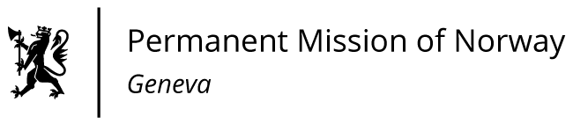

STATEMENT

41st UPR Session of the Human Rights Council

on the human rights situation in Philippines,

as delivered by Ms Jannicke Graatrud,

Minister, Deputy Permanent Representative.

Check against delivery
14 November 2022

President,
As one of the initial donors to the UN Joint Programme for the promotion and protection of human rights in the Philippines, Norway is pleased that progress has been made in the programme’s six focus areas.

Norway recommends that the Philippines:

1) ensures swift investigation, prosecution and accountability of perpetrators who contributed to the so-called 'war on drugs', including by providing effective remedies to victims;

2) promotes a safe and enabling environment for human rights defenders, including by promoting their legitimacy and importance, and ensuring that they are not subject to arbitrary arrests or detention;

3) re-examines libel provisions of the Revised Penal Code and the Cybercrime Prevention Act of 2012, to ensure that these laws are not used to limit freedom of expression;

4) implements the Responsible Parenthood and Reproductive Health Act of 2012, including by increasing access to modern contraceptives.

Thank you.

