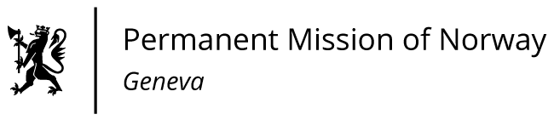

STATEMENT

41th UPR Session of the Human Rights Council

on the human rights situation in Algeria,

as delivered by as delivered by Ms Anniken ENERSEN

Minister Counsellor, Human Rights

Check against delivery
11 November 2022

President,
Norway welcomes Algeria as a member of the Human Rights Council for the period 2023-2025.
Norway recommends that Algeria;
1) ensures in law and in practice the rights to peaceful assembly, freedom of association and freedom of expression, including freedom of artistic expression, in compliance with the ICCPR;

2) adopts comprehensive legislation to prevent and combat violence against women with policies for implementation in line with the Constitution;

3) ensures the right to freedom of thought, belief and religion according to the Constitution;

4) cooperates fully with the human rights mechanisms, including by receiving the special procedures mandate holders of the UN Human Rights Council.
Thank you.

