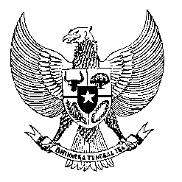

Permanent Mission
of the Republic of Indonesia to the UN, WTO,
and Other International Organizations
in Geneva

Statement
by the Delegation of the Republic of Indonesia
at the 41st Session of the UPR Working Group
Consideration of the UPR Report of India
10 November 2022

Mr. President,

My delegation thanks India for the presentation of their report.

Indonesia welcomes the progress that India has made since its last review, particularly with regard to ensuring universal access to affordable healthcare.

Indonesia offers the following recommendations:

First, to take steps towards improving access to health, especially access to maternal health so as to reduce maternal and child mortality;

Second, to strengthen efforts in ensuring food security, especially for the most vulnerable groups; and

Third, to enhance poverty alleviation efforts, especially through effective rural development programmes.

We sish India a successful review.

I thank you.

(Max: 0:55)

