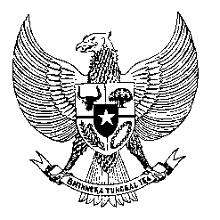

Permanent Mission
of the Republic of Indonesia to the UN, WTO,
and Other International Organizations
in Geneva

STATEMENT BY THE DELEGATION OF THE REPUBLIC OF INDONESIA
AT THE 41st SESSION OF THE UPR WORKING GROUP
CONSIDERATION OF THE UPR REPORT OF UK OF GREAT BRITAIN AND NORTHERN IRELAND
10 November 2022

Mr. President,

Indonesia thanks the UK Delegation for their national report.

We appreciate the UK Government’s commitment to the protection of women and girls from violence, and to increase number of women represented in Parliament, the judiciary and the police force.

Indonesia wishes to recommend the UK to:

- Take all necessary measures to end abuse and exploitation in immigration by integrating human rights standards in line with UK’s obligations under international law.

- Improve efforts to address discrimination and prejudice towards racial, ethnic and religious minorities including Muslim minorities.

- Take concrete measures to ensure the fulfilment of the right to adequate housing for all without discrimination to prevent homelessness.

We wish the UK success in this review and its full implementation.

Thank you.

Allocated time 1:00
118th speaker

