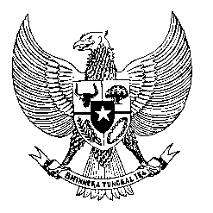

Permanent Mission
of the Republic of Indonesia to the UN, WTO,
and Other International Organizations
in Geneva

Statement
by the Delegation of the Republic of Indonesia
at the 41st Session of the UPR Working Group
Consideration of the UPR Report of Finland
9 November 2022

President,

My delegation thanks the delegation of Finland for the presentation of their national report.

To further improve progress in the promotion and protection of human rights in Finland, Indonesia offers the following recommendations:

- To enhance efforts in combating racism, xenophobia, and hate crimes, especially those targeting migrants and asylum seekers;
- To adopt legislation obligating regions and municipalities to establish effective preventive measures to combat violence against women,
- To consider the ratification of the International Convention on the Protection of All Migrants and Members of their Families, as a key instrument in guaranteeing a minimum degree of protection for all migrant workers.

Indonesia wishes Finland a successful review.

I thank you.

(Max: 1:15)

