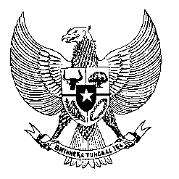

Permanent Mission
of the Republic of Indonesia to the UN, WTO,
and Other International Organizations
in Geneva

Statement
by the Delegation of the Republic of Indonesia
at the 41st Session of the UPR Working Group
Consideration of the UPR Report of the Kingdom of Morocco
8 November 2022

President,

Indonesia warmly welcomes the delegation of Morocco and thanks them for their report.

Indonesia welcomes the adoption of Morocco’s National Action Plan for Democracy and Human Rights since its third UPR cycle, and the range of progress that has been made in this regard.

To further improve progress in the promotion and protection of human rights in Morocco, Indonesia offers the following recommendations:

- To strengthen efforts in protecting the right to freedom of opinion and expression, peaceful assembly and association;
- To strengthen measures in ensuring access to health care services by persons with disabilities; and
- To continue efforts in producing measurable progress to prevent all acts of torture and ill-treatment, including during arrest, interrogation and detention.
Indonesia wishes the Kingdom of Morocco a successful review.

I thank you.

(Max: 0:55)

