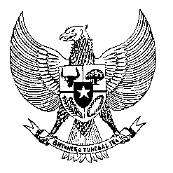

Permanent Mission
of the Republic of Indonesia to the UN, WTO,
and Other International Organizations
in Geneva

STATEMENT BY THE DELEGATION OF THE REPUBLIC OF INDONESIA
AT THE 41st SESSION OF THE UPR WORKING GROUP
CONSIDERATION OF THE UPR REPORT OF TUNISIA
8 November 2022

Thank you, Mr. President,

My delegation welcomes the delegation of Tunisia and thanks them for their presentation of national report.

We commend the successful establishment of Tunisia’s National Authority for the Prevention of Torture.

Indonesia wishes to offer the following recommendations:

- Strengthen efforts to promote disability-inclusive development in all areas including education, health, employment, and social activities.

- Step up efforts in reforming the national health system to strengthen the protection of the right to health and social coverage for all citizens;

- Continue to provide vocational trainings and economic integration programs for young people, women, and person with disabilities to enhance their access to formal employment and entrepreneurship.

We wish Tunisia success in this review and implementation of the accepted recommendations.

Thank you.

Allocated time 1:00
70th speaker

