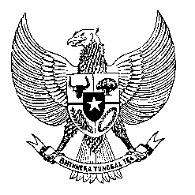

Permanent Mission
of the Republic of Indonesia to the UN, WTO,
and Other International Organizations
in Geneva

STATEMENT BY THE DELEGATION OF THE REPUBLIC OF INDONESIA
AT THE 41st SESSION OF THE UPR WORKING GROUP
CONSIDERATION OF THE UPR REPORT OF ECUADOR
7 November 2022

Thank you, Mr. President,

Indonesia thank the delegation of Ecuador for their presentation of its comprehensive national report.

We appreciate Ecuador’s leadership in the process of elaboration of a legally binding instrument on transnational corporations and other business enterprises with respect to human rights.

We also commend Ecuador’s efforts to protect the right to vote for persons with disabilities as well as the project for overseas voting procedures.

For this cycle, Indonesia recommends Ecuador to:

- Take relevant and necessary measures to reduce prison overcrowding including inter alia through implementation of alternative sentence.

- Strengthen efforts to eliminate violence and discrimination against women, including through raising awareness and education on equality of women and girls.

- Step up efforts to address the issue of child malnutrition, particularly in rural areas.

We wish Ecuador success in this review and its full implementation.

Thank you.

Allocated time 1:45
52nd speaker

