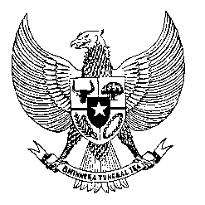

Permanent Mission
of the Republic of Indonesia to the UN, WTO,
and Other International Organizations
in Geneva

Statement
by the Delegation of the Republic of Indonesia
at the 41st Session of the UPR Working Group
Consideration of the UPR Report of the Kingdom of Bahrain
7 November 2022

Mr. President,

Indonesia thanks the delegation of the Kingdom Bahrain for their report.

Indonesia welcomes Bahrain’s enactment of its comprehensive module in addressing the COVID-19 pandemic.

To further improve progress in the promotion and protection of human rights in the Kingdom of Bahrain, Indonesia offers the following recommendations:

- To strengthen measures to protect and ensure the rights of migrant workers;
- To continue to enhance the promotion of interfaith dialogue and religious tolerance;
- To redouble efforts to enhance gender equality and women representation in public and political spheres, and
- To continue efforts in improving prison conditions and the treatment of people in detention, involving also possible bilateral and international cooperation.
Indonesia wishes the delegation of Bahrain a successful review.

I thank you.

(Max: 1:20)

