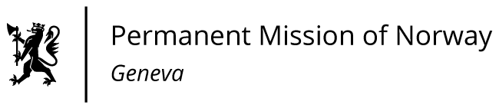

STATEMENT

41th UPR Session of the Human Rights Council

on the human rights situation in
the United Kingdom of Great Britain and Northern Ireland,

as delivered by Ambassador Tine Mørch Smith,

Permanent Representative of Norway in Geneva.

Check against delivery
10 November 2022

President,
Norway welcomes the United Kingdom’s ratification of the Istanbul Convention [on preventing and combating violence against women].
Norway calls upon the United Kingdom to ensure that any changes to the Human Rights Act of 1998 do not weaken [domestic safeguards or] its commitment to stand by its international human rights obligations.

Norway recommends that the United Kingdom
1) strengthens the protection against sexual harassment in the workplace affecting women workers with disabilities and LGBTIQ workers, in accordance with the ILO Convention No. 111;

2) Strengthens the efforts to identify victims of human trafficking and forced labour, increases their access to legal and psychological assistance, and ensures prosecution of human traffickers, [in line with recommendations from GRETA];

3) takes further measures to protect children from physical punishment and ensures the right of every child to adequate standard of living, in accordance with the Convention on the Rights of the Child.

Thank you.

