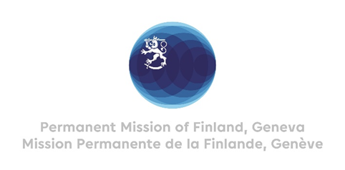
41. Session of the Universal Periodic Review
16 November 2022

The Fourth Universal Periodic Review of Finland at the UN Human Rights Council

Mr. Vice President, Distinguished Delegates and Members of the Troika,

I would wish to begin by expressing, on behalf of the Government of Finland, our gratitude for the dialogue we had last Wednesday. As our Minister for Foreign Affairs Mr. Haavisto stated, The UPR is an important tool in securing that all States’ human rights commitments are implemented and put into concrete action. As a member of the Human Rights Council, Finland recognizes a special obligation to uphold the highest standards in the promotion and protection of human rights.

I would like to thank the Vice President, Members of the Troika and Member States for their engagement in the process. I would also wish to thank the Secretariat, the Conference Services and Interpreters for all their support.

We had the pleasure of examining the recommendations received together with the Secretariat and the Members of the Troika – Luxembourg, Mexico and Somalia. We truly appreciate the work they have done in drafting the report and their valuable contribution to our review.

I would also like to thank all the delegations for their active participation and for the excellent and timely recommendations that we received. We appreciate all the work you have put into this.

The Government of Finland will carefully examine all the 229 recommendations received and will respond to them in the 52nd session of the Human Rights Council in March 2023.

The Government of Finland chose this way forward especially for two reasons:

Firstly, to allow for all ministries to be involved in the decision-making. The recommendations received will be reviewed by the Government's Network for Fundamental and Human Rights, which has representatives from all ministries. This Network is also responsible for monitoring and assessing the implementation of the UPR recommendations. Engaging everyone at this stage not only enhances human rights cooperation between the government ministries but also increases their ownership in the process.
Secondly, as we place great value on active cooperation with civil society, we wish to engage them at this part of the process. We will listen closely to their views on the recommendations received and will organise a public meeting where the authorities and non-governmental organisations may interact. I would also wish to encourage CSOs to take part in the dialogue during the Human Rights Council March session, when the outcome of Finland’s review is being discussed.

Now that the fourth UPR cycle has begun, Finland is honoured to be again one of the first countries reviewed. We also recognize the responsibility it entails and that the success of the mechanism very much depends on its impact on the ground. We will do our best, together with national stakeholders, to implement the recommendations.

In our view, the UPR provides an important channel for reflecting on national challenges and achievements. Conclusions and recommendations from the UPR process will surely enable further promotion of the human rights situation in Finland.

To conclude, I would like to reiterate our strong support and commitment to the UPR process.

Thank you.

