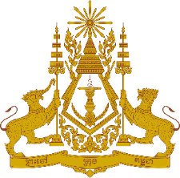
PERMANENT MISSION OF THE KINGDOM OF CAMBODIA
TO THE UNITED NATIONS AT GENEVA

Statement of Cambodia
At the 40th Session of the UPR Working Group
UPR of the Syrian Arab Republic
24 January 2022

Mr. President!
- Cambodia recognizes Syria’s concrete endeavours to fulfil its obligations under the treaty body mechanisms, and its cooperation with the special procedure mandate holders.
- We also recognize Syrian government's commitment to strengthening the institutional framework to protect human rights through, among others, creating national committees aiming at protecting fundamental human rights in the sectors of education, health, access to water and sanitation.
- In the constructive spirit, Cambodia would like to offer two recommendations:
  - Consider adopting a national policy to empower rural women and enhance their economic and social role in the country.
  - Continue efforts to exchange experiences and expertise with other countries in the areas of training health workers.

- Finally, I wish the delegation of the Syrian Arab Republic every success in this exercise.
I thank you!
*****

