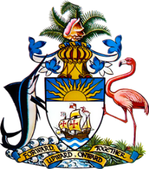

Statement by Ms. Sasha Dixon, Second Secretary
Permanent Mission of The Bahamas to the United Nations Office and Other International Organizations in Geneva
at the 40th Session of the Universal Periodic Review Working Group
Presentation of National Report by the Government of Uganda
Thursday 27 January, 2022

The Bahamas thanks Uganda for presenting the national report and commends the progress made since the last review.
We congratulate Uganda on positive steps taken to promote and protect human rights through the development of awareness-raising campaigns and policy reforms, in addition to efforts to strengthen democratic institutions, despite the significant challenges arising from the COVID-19 pandemic.

Other noteworthy efforts include the development of a National Action Plan for the Prevention of Trafficking in Persons and National Referral Guidelines for Management of Victims of Trafficking.

In a constructive spirit, The Bahamas recommends that Uganda:

- Allows for more legitimate opposition participation in elections, including by guaranteeing freedom of peaceful assembly, of expression and of association,

- Strengthens social safety nets to reduce the number of children forced to live and work on the streets
and
- Prioritizes the full implementation of the National Strategy to End Child Marriage and Teenage Pregnancy.
We wish Uganda every success in this UPR process.

I thank you.

