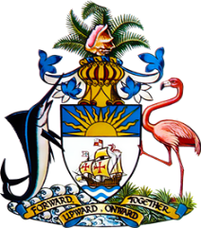

Statement by Ms. Sasha Dixon, Second Secretary
Permanent Mission of The Bahamas to the United Nations Office and Other International Organizations in Geneva
at the 40th Session of the Universal Periodic Review Working Group
Presentation of National Report by the Government of Timor-Leste
Thursday 27 January, 2022

The Bahamas thanks Timor-Leste for presenting the national report and commends progress made since the last review.

We positively acknowledge steps taken, despite the challenges of the COVID-19 pandemic, including the implementation of National Plans of Action to protect and promote the rights of children, to combat gender-based violence and to eradicate hunger and malnutrition. We also positively note pandemic response and recovery efforts, including the distribution of monetary subsidies, food and local products.

Also commendable are efforts by Timor-Leste to strengthen the justice system, including the use of mobile trials to increase access to justice in rural areas.

In a constructive spirit, The Bahamas recommends that Timor-Leste:

(i) Ratifies the Convention on the Rights of Persons with Disabilities.

and

(ii) Ensures adequate funding in the national budget to provide food security, safe water and health care, including for people living in rural areas and in line with National Plans and initiatives.

As a fellow Small Island Developing State (SIDS), we recognise the challenges faced by Timor Leste, including due to the disproportionate threats of climate change. We therefore also encourage Timor Leste to avail itself of technical assistance and capacity-building support, in accordance with its human rights priorities.

We wish Timor-Leste every success in this UPR process.

I thank you.

