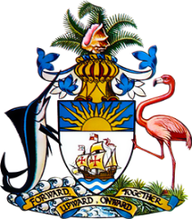

Statement by Ms. Kristie Russell, Third Secretary
Permanent Mission of The Bahamas to the United Nations Office and Other International Organizations in Geneva
at the 40th Session of the Universal Periodic Review Working Group
Presentation of National Report by the Government of Lithuania
Wednesday 26th January, 2022

The Bahamas thanks the delegation of Lithuania for the presentation of the national report and the updates provided today.
We commend Lithuania for strides made toward fostering a fairer and more inclusive society. We particularly acknowledge strengthened measures to protect the rights of children, youth and persons with disabilities. Especially noteworthy in the area of gender equality are milestone achievements of female representation in leadership and decision-making roles and the highest employment rate among women within the European Union.
In a constructive sprit, The Bahamas recommends that Lithuania:

- Fully implements the 2020-2022 Action Plan for combating trafficking in human beings and considers conducting a widespread anti-trafficking public awareness campaign,
- Amends the Law of Equal Treatment to include “colour” and “descent” among the prohibited grounds of discrimination
and
- Takes concrete steps to combat gender stereotyping regarding the roles of women and men in the family and in society and ensures that laws and policies do not contribute to entrenching these.

We wish Lithuania every success in this UPR process.

I thank you.

