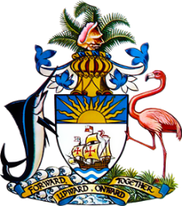

Statement by Mr. Frank Davis, Deputy Permanent Representative
Permanent Mission of The Bahamas to the United Nations Office and Other International Organizations in Geneva
at the 40th Session of the Universal Periodic Review Working Group
Presentation of National Report by the Government of Venezuela
25 January, 2022

The Bahamas thanks Venezuela for the national report presented and welcomes the engagement in this UPR process.
In a constructive spirit, The Bahamas recommends that Venezuela:

- Takes effective measures to restore the independence of the justice system;
- Publishes the national budget to allow for public oversight
- Takes all necessary measures to prevent acts of persecution and targeted repression, including based on political affiliation, and ensures that human rights defenders are protected without discrimination on any grounds
and
- Investigates allegations of discrimination in access to food assistance and other social protection programmes, guarantees equal access to such programmes and makes transparent the criteria used to determine eligibility.
We wish Venezuela every success in this UPR process.

I thank you.

