Jamhuuriyadda Federaalka Soomaaliya  Ergada Joogtada Soomaliyeed ee Qaramada Midoobey ee Geneva | 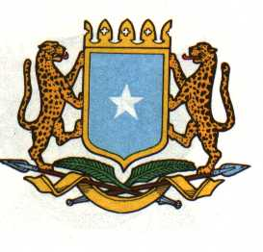 | الفيدرالية ل جمهورية الصوما  البعثة الدائمة لجمهورية الصومال بمكتب الأمم المتحدة بجنيف وبالوكالات المتخصصة بسويسرا
THE FEDERAL REPUBLIC OF SOMALIA
Permanent Mission of the Federal Republic of Somalia to the United Nations Office at Geneva and other International Organizations in Geneva

Statement by the Delegations of Somalia by
H.E. Ebyan Mahamed Salah
At the Review of the Republic of Sudan at the 40th session of the UPR Working Group on February 2, from 09:00-12:30 PM, in the Assembly Hall of the Palais des Nations
in Room XX, Geneva.

Thank you, Mr. President,
The Federal Republic of Somalia welcomes the delegation from the Republic of Sudan and the comprehensive National report presented to the Council.

My delegation appreciated Sudan’s commitment to make progress on the promotion and protection of Human Rights.

Somalia Recommends the following:

- Continue efforts towards peace and national reconciliation to improve the human rights situation in the country.

- Continue to cooperate with the office of the High Commissioner for Human Rights and other UN bodies.

- Strengthen Programs and Polices related to social development and poverty reduction.

- Take further steps to fight against harmful practices against women, in particular female genital mutilation.

We wish the Republic of Sudan a very successful UPR review

I Thank you Chair.

February 2, 2022

